Alice Code-Writing/Programming/Creating an Animation
using Alice 3.1/3.2 2017
Name____________________
- The Math Path example shows mathematical reasoning and is an example of 7th grade math skill and ability (20 Points).

- A one page storyboard with scene ideas, camera settings and text dialogue/conversation (40 Points) Homework grade

- Did the student code edit/write code blocks sufficient to animate the story? (200 Points) A 200-176 points B 174 – 150 points C 148 - 120 points D 118 – 80 points Unacceptable 78 or fewer points

- Did the student complete four basic camera changes to make the animation interesting? (30 Points)

- Is there at least one camera marker to locate the beginning of a scene or change of scene. (20 points)

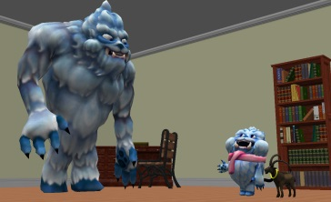
- Does the Alice world work effectively? [No bugs] (20 Points)

- Did the student present the “story” correctly (according to plan/script) OR changes have been made? (10 Points)

- The spelling, grammar, and capitalization is appropriate? (10 Points)

- The animation runs one entire scene related to a math path experience per student. (10 Points)

- Team-work existed allowing the partner(s) to show and share learned skills. (20 points)

- The scenes are related by characters or design. (20 points)

